Chikko Café website manual

# FileZilla Instructions

1. Step One

Download FileZilla : <https://filezilla-project.org/download.php?type=client>

1. Step Two

Configure manual

FTP Username: [admin@chikko.com.au](mailto:admin@chikko.com.au)

FTP Password: ThaoWhite  
FTP host server: 166.62.10.225  
FTP & explicit FTPS port:  21

1. Step Three  
   Open your FileZilla FTP client.
2. Step Four

Fill information

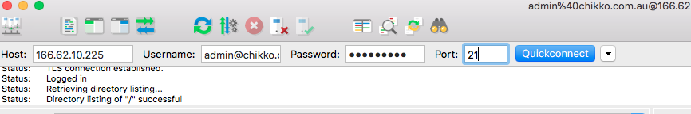

1. Step Five  
   Click the Connect button to connect to your FTP server.

# Edit food name

Open *ListFood* folder

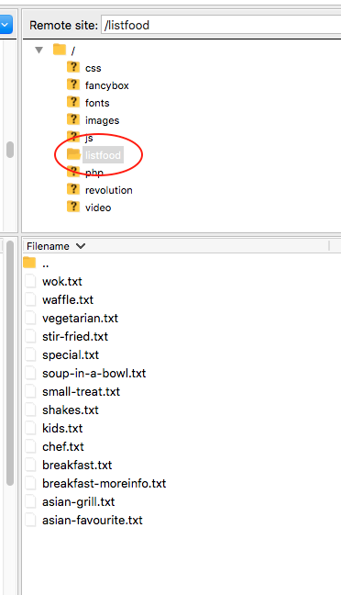

Choose file > right click > View/edit

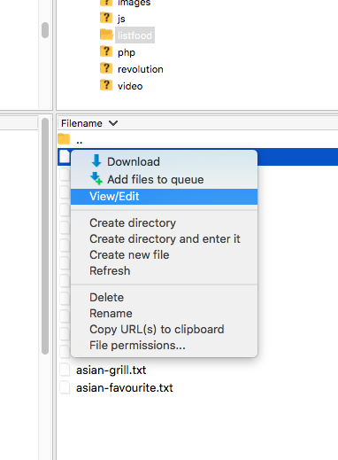

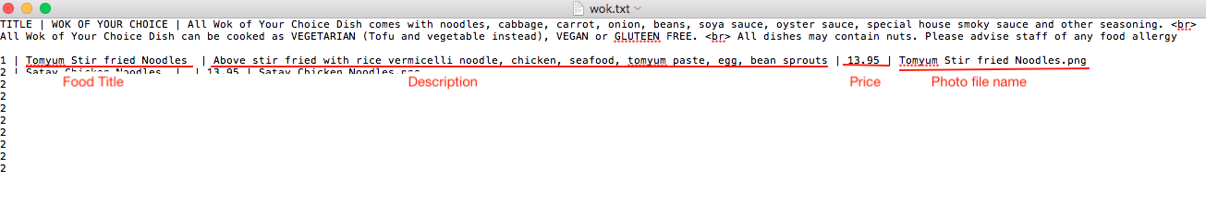

# Upload photos

**Photos should be PNG format with transparent background**

Open images/ dish folder

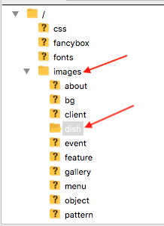

Select photos on left window

Right click

Chose Upload

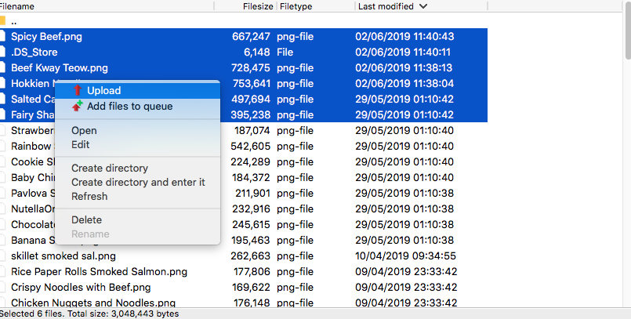

# Change Website information

On root folder

Open chikko-info.php

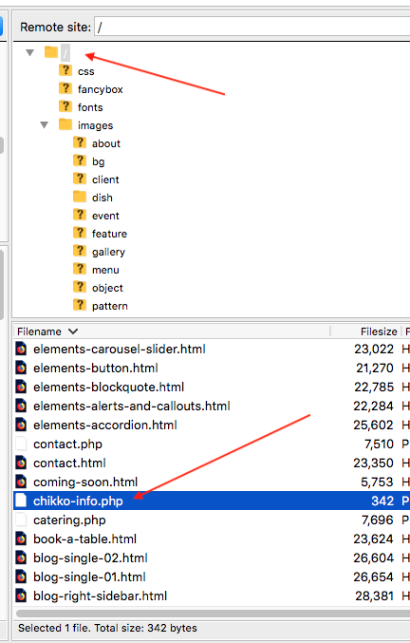

Open to edit

